



ME CITY

A game to explore the energy market

|  |  |
| --- | --- |
| Issue 1.0 | Author |
| 3/07/2018 | Jordan Parezys  Ryan Bax  Laura de Kort |



ferrantilogo.wmf

Table of Contents

2 Instructions main menu 3

2.1 Play 3

2.2 Levels 3

2.3 Highscores 3

2.4 Quite 4

3 Game 4

3.1 Introduction 4

3.2 Level 2: supplier 5

# Instructions main menu

When opening the game, you need to fill in your name. This to keep your highscores saved.

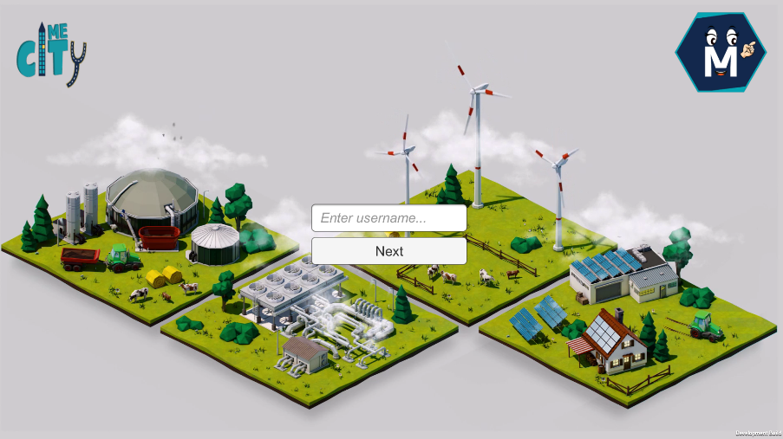

When you did that, the main menu will appear.

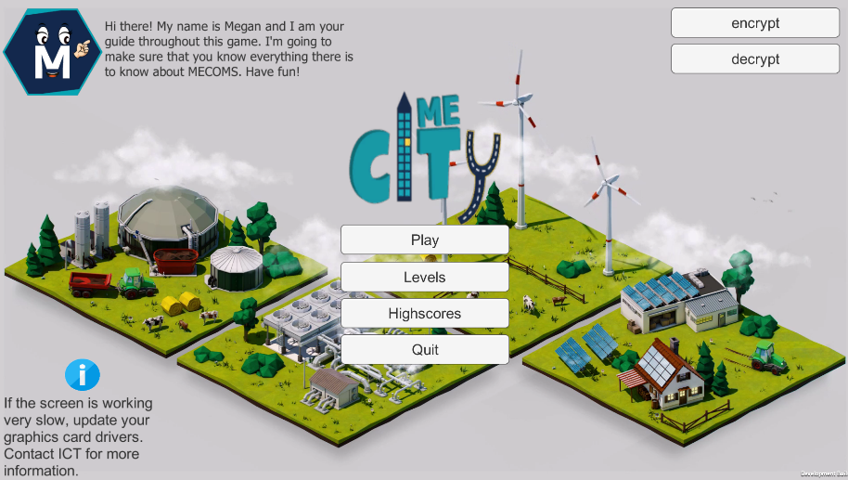

## Play

When you click here, another info screen will appear. Here you will be introduced to Megan, the info icon who will help you throughout the game. You can also see how the controlling system works. When you click next, you will begin with the introduction level.

## Levels

If you click here, you can choose which level you want to play. Easy when you want to do one specific level all over again to see what the tasks are from this person. When you click on start, you will automatically go through all the levels.

## Highscores

When you click here, you can see the highscores from the players before you. How bigger the fish, how bigger the highscore. When you click in the right corner above ‘highscore’ you can see the highscores in detail. Will your fish be the biggest of them all?

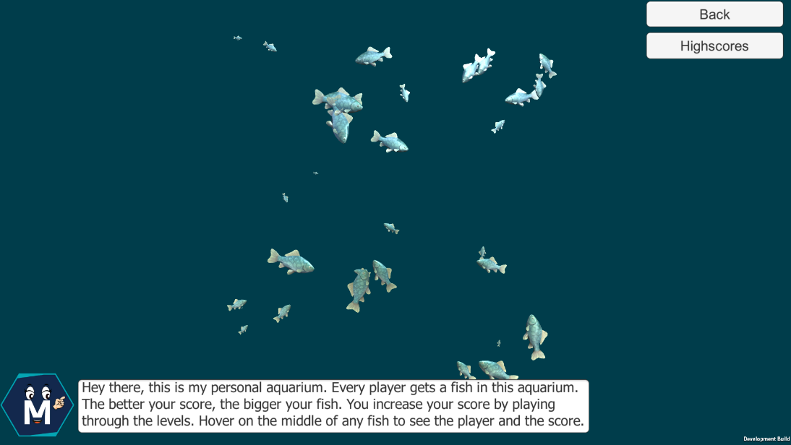

## Quit

If you click here, the game will shut down.

# Game

## Introduction

When you click play, Megan will follow to explain the control system during the game. When you click close, the actual introduction of the game will start. If you do what Megan says you should do, you only have to read the explanations of the energy market. In this level you should just get all the info you need. In the right corner above, you can click pause. When you do that, a little pop up will appear.

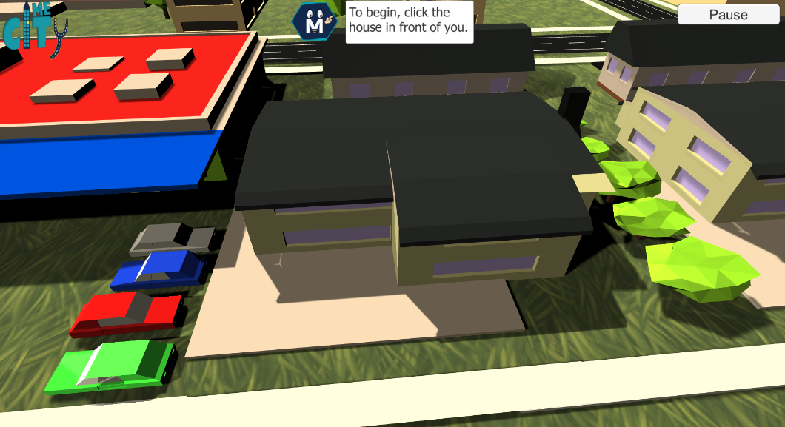

In this pop up you can see again how the control system works. You can also continue the game or click on exit. If you do so, you will go back to the main menu again.

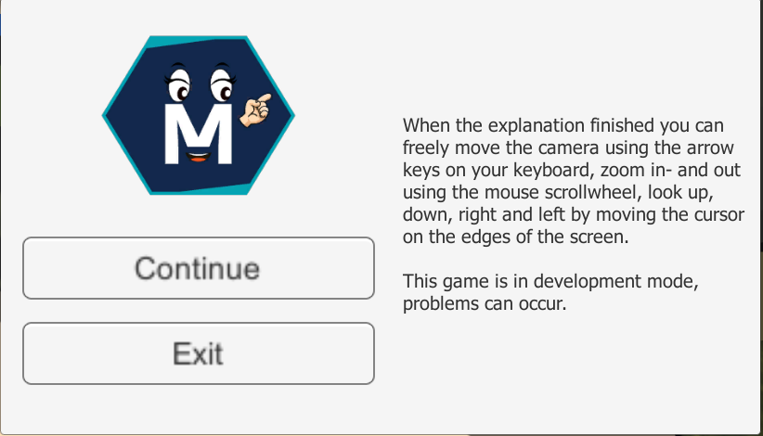

## Level 2: supplier

When you start with the second level, you see there are boxes above all the houses. This shows you which houses are your customers or which houses belong to another company. The main goal of this level is to gain all the houses for your company. This by turning all the houses blue, the color of our company.

First you have the customer’s happiness in general. This you can see on the right side below. You can make your customers more happy by answering the events right, by making sure there are no outages…

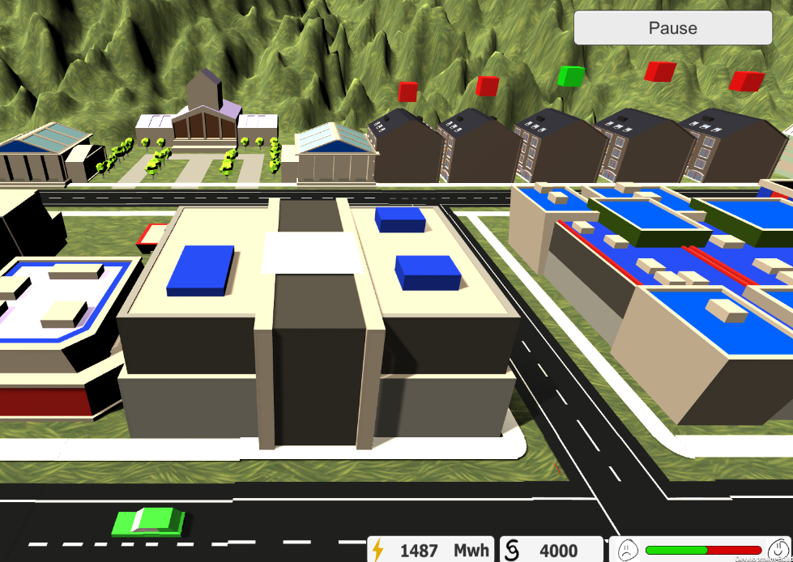

If you click on one of the houses, a pop up will appear. Here you can see how much happiness in general you should have before a customer switches to your company. You can also see the preference of energy the customer have. If you see he wants green energy, it’s your task to buy more green energy on the market in order to gain this customer for your company. You can also see the preferences of high and low tariff. This shows which prices the customer is looking for.

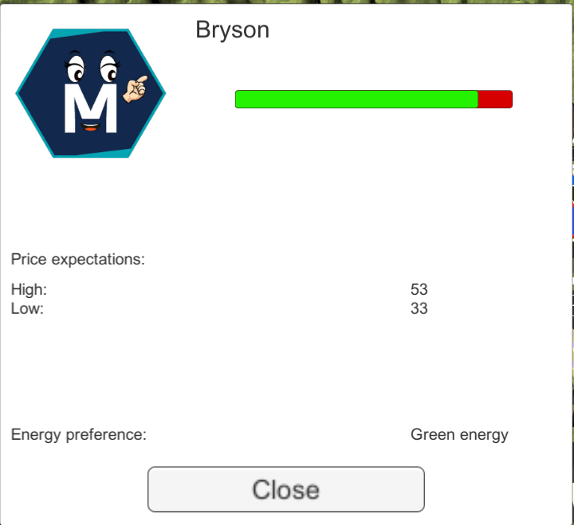

If you click on the money button, another pop up will appear, here you can adjust your high and low tariff in order to win more customers. Keep in mind you still have to pay your bills. You can’t do it for free because it will give you more customers. Keep in mind you don’t go bankrupt, or it’s game over!

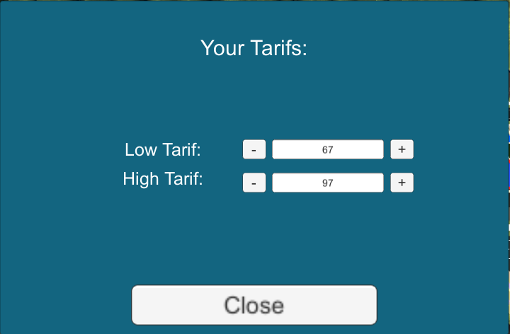

If you want to buy more energy, you can go to the energy market by clicking on the lightning bolt button. Here you can choose how much energy you want to buy for different prices. If the game continues, there will be the option to buy green energy as well. Make sure you don’t go below 1000 of energy because then there will be outages and you will lose customers. If you buy too much energy at the same time, you will get fines to pay due to the waste of energy.

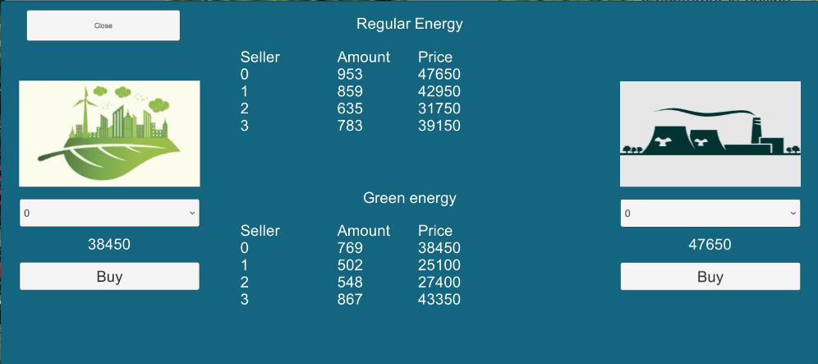

During the game you will get events. A customer can call you with a problem, you can get invoices… Your happiness of your customers and your money depends on the answers you give. You can ignore a phone call, but that isn’t a good customer service so you will lose clients.

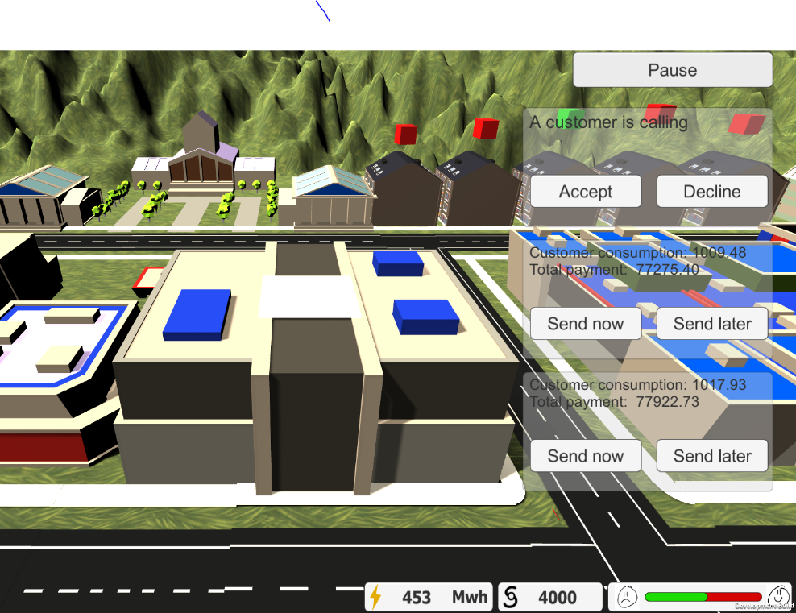

In general: you have to win more customers for your company and making your company a cashcow!

In order to win, you have to gain 80% of the customers for your company, answer 25 questions correctly after each other, or reach a certain amount of money. You go bankrupt if you go beneath the 0 euros. You can reach a minus of energy, but then there will be imbalance what costs you a lot.